**A**

**Project Report**

**On**

**E-Blood Bank Management System**



**Prepared by**

14CE107 Varsh Patel

14CE145 Drashti Vashi

**Under the guidance of**

Prof. Ronak Patel

**Submitted to**

Charotar University of Science & Technology

Degree of Bachelor of Technology

in Computer Engineering

CE324 - Software Group Project

Of 6th Semester of B.Tech

**Submitted at**



**U. & P. U PATEL DEPARTMENT OF COMPUTER ENGINEERING**

**Faculty of Technology & Engineering, CHARUSAT**

**Chandubhai S. Patel Institute of Technology**

**At: Changa, Dist: Anand – 388421**

**January-May 2017**



**CERTIFICATE**

This is to certify that the report entitled “E-Blood Bank Management System” is a bonafied work carried out by **Mr. Varsh Patel (14CE107)** and **Ms. Drashti Vashi (14CE145)** under the guidance and supervision of Prof. Ronak Patelfor the subject **Software Group Project (CE324)** of 6th Semester of Bachelor of Technology in **Computer Engineering** at Faculty of Technology & Engineering (C.S.P.I.T.) – CHARUSAT, Gujarat.

To the best of my knowledge and belief, this work embodies the work of candidate themselves, has duly been completed, and fulfills the requirement of the ordinance relating to the B.Tech. Degree of the University and is up to the standard in respect of content, presentation and language for being referred to the examiner.

|  |  |
| --- | --- |
| Under the supervision of,  Prof. Ronak Patel  Assistant Professor  U. & P. U Patel Dept. of Computer Engineering  C.S.P.I.T., CHARUSAT-Changa. |  |
| Dr. (Prof.) Amit Ganatra  Dean,  Faculty of Technology & Engineering  Head, U. & P. U Patel Department of Computer Engineering  C.S.P.I.T., CHARUSAT- Changa, Gujarat. | |

**Chandubhai S Patel Institute of Technology (C.S.P.I.T.)**

**Faculty of Technology & Engineering, CHARUSAT**

At: Changa, Ta. Petlad, Dist. Anand, PIN: 388 421. Gujarat

**Abstract**

This project is a web portal for social services to play a best part for the society and humanity. There are N number of blood bank today in India but still most of the death occurs due to unavailability of blood at the right place at the right time. We have collaborated to 3 or more hospitals that can directly book and order for blood online and get it delivered within a time frame of an hour or less. Donors can directly donate blood to our nearest collection centers that can be found and reached easily by google maps within minutes. Once testing and required stuff is performed the blood is then ready to get delivered if required as per request by hospitals. Hospitals to buy maximum blood get featured on our website. Donors are allotted with points and various basis regarding their social services top donors with maximum points also get featured at our website to motivate and encourage others.

**Acknowledgement**

I am thankful to my internal guide Prof. Ronak Patel from CHARUSAT for his constant and valuable guidance at each and every stage of the project. I would like to thank all my family members and friends for their support. Also extending my thanks to the rising technology of .NET and Microsoft that made me to select this project with great passion in order to learn and grab maximum from it.

**Table of contents**

Abstract

Acknowledgement

Chapter1 Introduction

1.1. Purpose

1.2. Scope

1.3. Definitions, acronyms & abbreviations

1.4. References

1.5. Overview

Chapter 2 Overall Description

2.1. Product perspective

2.1.1. System interfaces

2.1.2. User interfaces

2.1.3. Hardware interfaces

2.1.4. Software interfaces

2.1.5. Communications interfaces

2.1.6. Memory constraints

2.1.7. Operations

2.1.8. Site adaptation requirements

2.2. Product functions

2.3. User characteristics

2.4. Constraints

2.5. Assumptions and dependencies

Chapter 3 System Analysis

3.1 Requirements of New System

3.1.1 Functional Requirements

3.1.2 Non Functional Requirements

3.2 Feasibility Study

3.3 Class Diagram

3.4 Sequence Diagram

3.5 Functions of system

* 1. Context Diagram

3.7 Data Flow Diagram (0 and 1 level or higher)

* 1. Selection of Hardware and Software and Justification

Chapter 4 Project estimation

* 1. Estimation technique used
  2. Effort resource, cost, project duration estimation

Chapter 5 Schedule in which

* 1. Breakdown structure
  2. Task network representation
  3. Gantt chart representation
  4. Pert chart representation

Chapter 6 Project resources

* 1. People
  2. Hardware & Software

Chapter 7 Project tracking & control plan

Chapter 8 System Design

* 1. System Application Design

8.1.1 Method Pseudo code

Chapter 9 Implementation Planning

a. Implementation Environment (Single vs Multi user, GUI vs Non GUI)

* 1. Program/Modules Specification(refer appendix C)
  2. Coding Standards

Chapter 10 Testing

10.1 Testing Plan

10.2 Learn More About Us

10.2.1 How Does It Work

10.2.2 Workflow

10.2.3 Types Of Test Cases

10.2.4 Areas Covered

Chapter 11 Limitation and Future Enhancement

Chapter 12 Conclusion and Discussion

1. Self-Analysis of Project Viabilities
2. Problem Encountered and Possible Solutions
3. Summary of Project work

**CHAPTER 1 INTRODUCTION:**

**1.1. PURPOSE:**

The main purpose of the specification is to guide the web developer about the web portal and the development structure, requirements and the input and output feature.

**1.2. SCOPE:**

The E-Blood Bank Management System has the ability to provide online platform for blood bank services and its features just at your fingertips within a form of web portal

.

BENEFITS:

* Blood delivery at door steps.
* Hospitals can order online for blood.
* Efficient.

OBJECTIVES:

* Reduce risk of handling.
* Fast Delivery.

**1.3. DEFINITIONS, ACRONYMS AND ABBREVIATION:**

* EBBMS – E-Blood Bank Management System
* BB – Blood Bank
* SSMS – SQL Server Management Studio
* SS – Social Service

**1.4. REFERENCES:**

The books and materials referred during the pre-development stages of the project include:

* <https://msdn.microsoft.com/>
* <http://www.wikipedia.org>
* http://www.google.com

**1.5. OVERVIEW:**

Section I gives a brief introduction about the document and the objectives of the software. The overall description such as system interface, software interface, hardware interface, communication interface are discussed in section II and the software product featured section III.

**CHAPTER 2 OVERALL DESCRIPTION:**

**2.1. PRODUCT PERSPECTIVE:**

The EBBMS web portal works on your web browser efficiently for ordering blood online when required and get ensured for fast and reliable delivery within hour or less.

**2.1.1. System Interfaces:**

Home page with informative video about the blood group and its compatibility.

Major services can be directly accessed from home page with all the information on our hospital partners at the bottom.

**2.1.2: User Interfaces:**

User can easily navigate throughout the web pages and get what they need.

Online order form and Donor list is readily available.

With few clicks here and few clicks there you can ensure the delivery at your door steps of hospitals.

**2.1.3: Hardware interfaces:**

* Web service for PCs and Mobile browsers.

**2.1.4: Software Interfaces:**

|  |  |  |
| --- | --- | --- |
| NAME | VERSION | SOURCE |
| Internet Browser | Any | Microsoft |

**2.1.5: Communication Interface:**

This application can run on Internet Facility.

**2.1.6: Memory Constraints:**

The system would require a minimum requirement in order to use the web portal.

**2.1.7: Operations:**

The user can easily travel through bunch of web pages from simple clicks on menu bar and rest areas. Full knowledge on blood groups and its compatibility has been given on the home page only. In depth knowledge for the same has been provided as a service. Donor can directly donate blood at the nearest collection center. Whereas, hospital can directly request for blood online with form readily available online.

**2.1.8: Site Adaptation Requirements:**

The application requires no special modifications to adapt to particular installations except for the files that are required to be re-created.

**2.2. PRODUCT FUNCTIONS:**

The major function includes:

* Providing a web portal for blood bank services.
* Donors can easily donate blood with nearest collection center.
* Donor can reach nearest blood center via help of google maps.
* Hospitals can request for blood online with form readily available.
* We ensure the delivery of blood within an hour or less.
* Informative data on blood group and awareness of the same.

**2.3 USER CHARACTERISTICS:**

It is sufficient that the users have a basic knowledge needed for operating the internet browser. There is no need for any experience or technical knowledge.

**2.4. CONSTRAINTS**

Not applicable.

**2.5. ASSUMPTIONS AND DEPENDENCIES**

Three of the major hospitals have already collaborated with us (CHARUSAT Hospital, Zydus Hospital, Shree Krishna Hospital).

**CHAPTER 3 SYSTEM ANALYSIS:**

**3.1 REQUIREMENTS OF NEW SYSTEM**

* + 1. **Functional Requirements**

R.1 Log In -

Description: Donors can Login to see their details and points earned.

Input: Credentials.

Output: Donor redirected to Donor_login page.

R.2 Services-

Description: User is presented with the list of services provided by the web application.

Input: On click event.

Output: Redirected to the services section.

R.3 Contact Us-

Description: User is redirected to the details of the developers and the external links to affiliated hospitals.

Input: On click event.

Output: Redirected to Contact_us section.

R.4 Locate Us-

Description: User can directly get the directions of the nearest collection centre in the city.

Input: Name of the city.

Output: Google maps.

R.5 Hall of Fame-

Description: User can see the leaderboard progress of the donors and the hospitals.

Input: On click event.

Output: Redirected to hof page.

R.6 Review-

Description: Donor can give their feedbacks and reviews about the services.

Input: Review

Output: List of reviews by donors.

**3.1.2 Non Functional Requirements**

* Usability- Software is easy to use.
* Reliable- There is less probability of failures.
* Portability- It can be used in Android Wear.
* Fault tolerance- In case of failure, the system can restart quickly.
* Extensibility- New features can be added to it in the future.
  1. **FEASIBILITY STUDY**

**Questionnaire with doctor:**

**Q: What is the rate of cases where patient has met with an accident?**

A: Twice in a day, we encounter a case where the patient has met with an accident.

**Q: How many causalities have occurred due to lack of blood availability?**

A: Sometimes, some blood groups are rare to find, if found it maybe at the blood bank away from city. So that by the time it reaches us, it happens to be late.

**Q: Have you affiliated your hospital to any blood bank in the city?**

A: Yes, we have affiliated with RED CROSS SOCIETY, but there should be increase in a number of blood bank because Red Cross alone is not able to handle all the blood requirements.

**Q: Would you like to affiliate your hospital with a private blood bank?**

A: Yes, if it is trust worthy, I would love to.

**Q: Would you prefer a blood bank which is online 24x7 accessible just a click away?**

A: That would be a great option if it serves the need in time.

**Q: We are planning to offer the delivery service which is solely responsible on us. Will that option be reviewed by you?**

A: That would be of great help if the delivery is timely and accurate.

Q: Do you have 24*7 internet access at your hospital?

A: Yes.

**3.3 CLASS DIAGRAM**

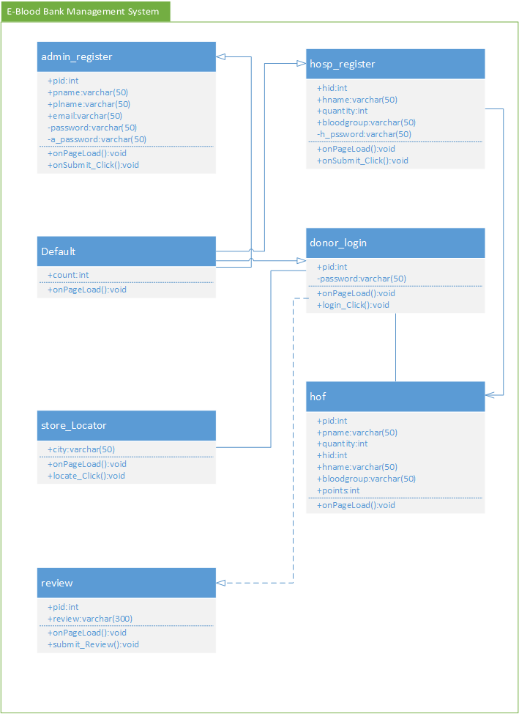

**3.4 SEQUENCE DIAGRAM**

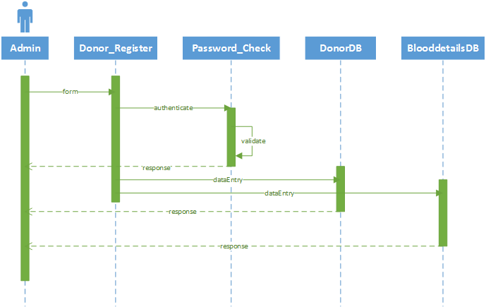

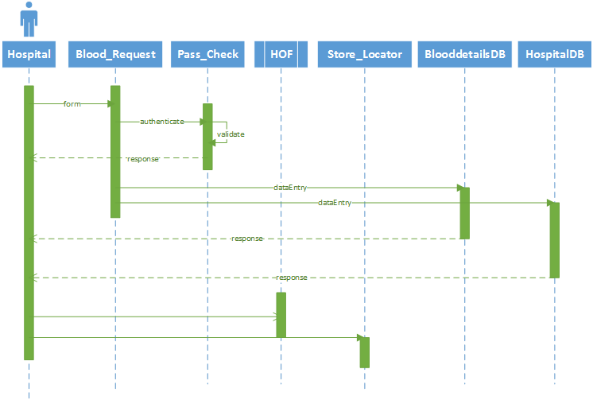

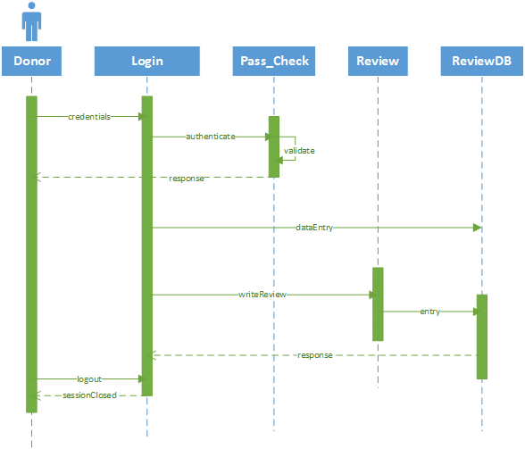

**3.5 FUNCTIONS OF SYSTEM**

* Providing a web portal for blood bank services.
* Donors can easily donate blood with nearest collection center.
* Donor can reach nearest blood center via help of google maps.
* Hospitals can request for blood online with form readily available.
* We ensure the delivery of blood within an hour or less.
* Informative data on blood group and awareness of the same.
  1. **CONTEXT DIAGRAM**

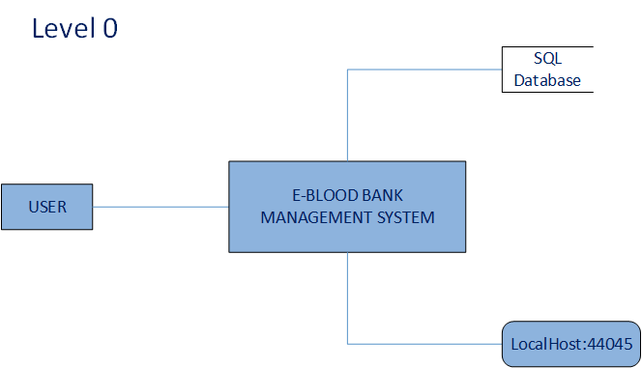

* 1. **DATA FLOW DIAGRAM**

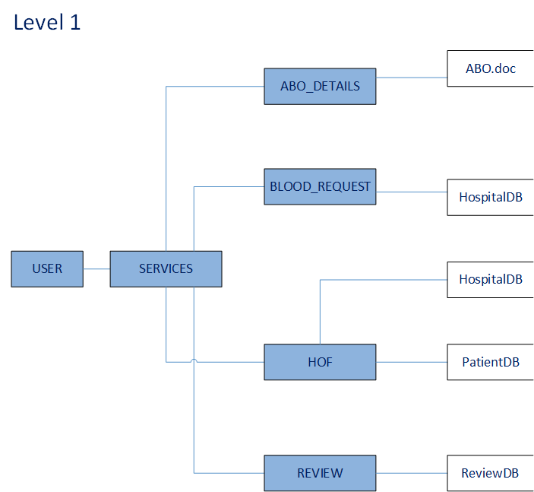

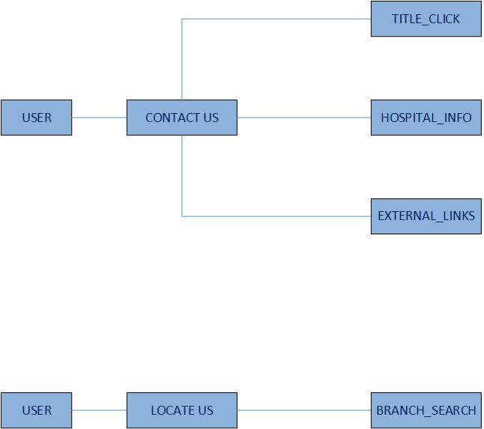

**3.8 SELECTION OF HARDWARE AND SOFTWARE AND JUSTIFICATION**

We have selected Visual Studio 2015 for .Net C# web programming. Team collaboration and merging of project was done through Team Foundation Server (TFS). For bank end database functionality we have used SSMS.

**CHAPTER 4 PROJECT ESTIMATION:**

**4.1 ESTIMATION TECHNIQUE USED:**

The project size is a measure of the problem complexity in terms of the effort and time required to develop the product. Currently, two metrics are popularly being used to estimate size: Line of code (LOC) and function point (FP).

* 1. **EFFORT RESOURCE, PROJECT DURATION ESTIMATION:**

|  |  |  |  |  |  |  |  |
| --- | --- | --- | --- | --- | --- | --- | --- |
| **Parameters** | **Count** |  | **Simple** | **Average** | **Complex** |  | **Total** |
| No. of user Input | 3 | X | 3 | **4** | 6 | = | 12 |
| No. of user Output | 2 | X | 4 | **5** | 7 | = | 10 |
| No. of Inquires | 3 | X | 3 | **4** | 6 | = | 12 |
| No. of Files | 2 | X | 7 | **10** | 15 | = | 20 |
| external Interface | 2 | X | 5 | **7** | 10 | = | 14 |

**Complexity Weight Factor:**

|  |  |  |
| --- | --- | --- |
| **Sr. No.** | **Factors** | **Weights** |
| 1. | Does the system require reliable backup and recovery? | **1** |
| 2. | Are data communication required? | **3** |
| 3. | Are there distributed processing functions? | **1** |
| 4. | Is performance critical? | **3** |
| 5. | Will the system run in an existing, heavily utilized operational environment? | **2** |
| 6. | Does the system require online data entry? | **5** |
| 7. | Does the on-line data entry require the input transactions to be built over multiple screens or operation? | **5** |
| 8. | Are the master file updated on-line | **4** |
| 9. | Are the inputs, outputs, files, or inquiries complex? | **4** |
| 10. | Is the internal processing complex? | **3** |
| 11. | Is the code designed to be reusable? | **3** |
| 12. | Are conversion and installation included in the design? | **4** |
| 13. | Is the system designed for multiple installations in different organizations? | **5** |
| 14. | Is the application designed to facilitate change and ease of use by the user? | **5** |

|  |  |
| --- | --- |
| **Weight** | **Degree Of Influence** |
| 0 | No Influence |
| 1 | Incidental |
| 2 | Moderate |
| 3 | Average |
| 4 | Significant |
| 5 | Essential |

**FP Count:**

FP = count total*[0.65+0.01 *∑(Di)]

FP = 48* [0.65+0.01*68]

FP = 76.84

**Function Point is: 76.84**

Line of code (LOC) = FP*30 = 76.84*30 = 2305.20

KLOC = 2.30520

**Software Project Type**

|  |  |  |  |  |
| --- | --- | --- | --- | --- |
| **Type** | **ab** | **bb** | **cb** | **db** |
| Organic | 2.4 | 1.05 | 2.5 | 0.38 |
| **Semi-detached** | **3.0** | **1.12** | **2.5** | **0.35** |
| Embedded | 3.6 | 1.20 | 2.5 | 0.32 |

Effort = ab*(KLOC) ^bb

= 3.0*(2.30520) ^1.12

= 7.64 PM

Tdev = cb * (Effort) ^db

= 2.5*(7.64) ^0.35

= 5.09 Months

**CHAPTER 5 SCHEDULE IN WHICH**

* 1. **BREAKDOWN STRUCTURE**

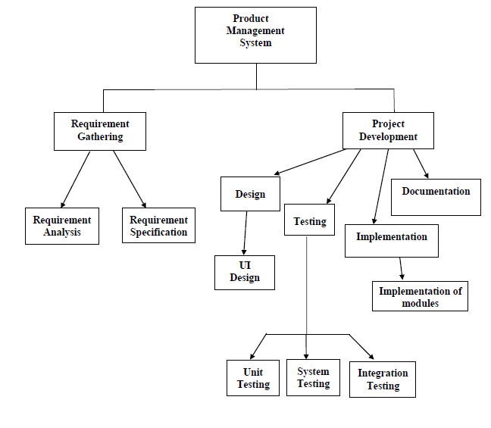

**5.2 TASK NETWORK REPRESENTATION**

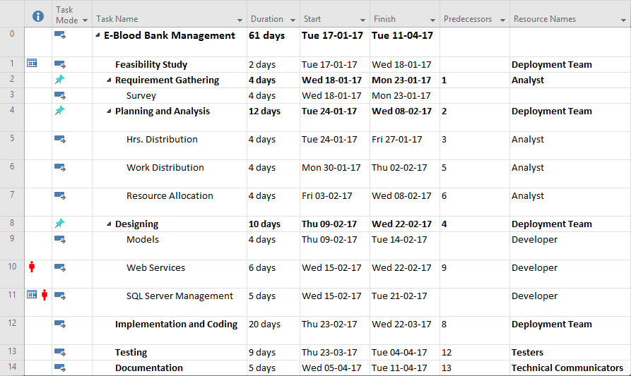

* 1. **GANTT CHART REPRESENTATION**

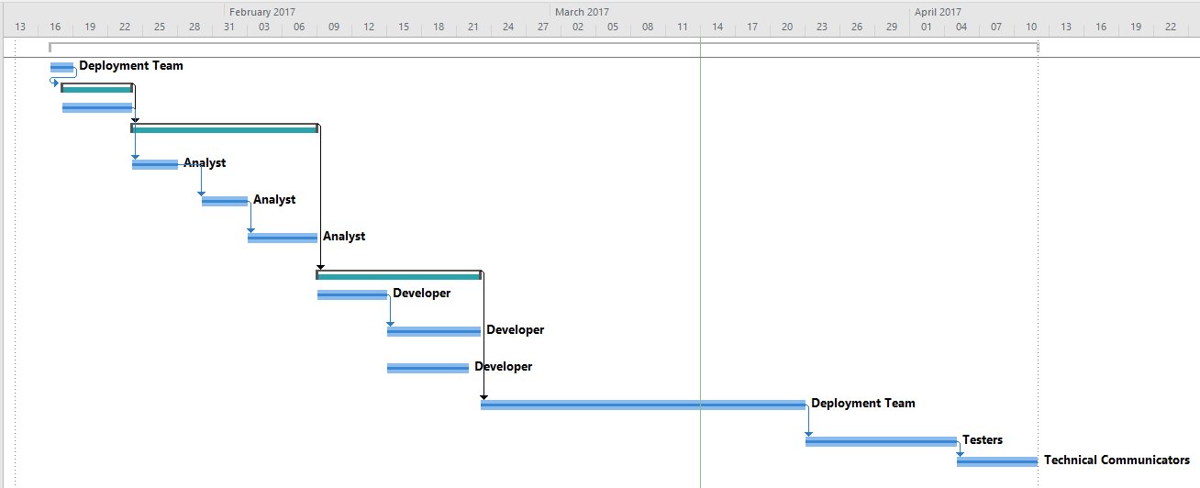

* 1. **PERT CHART REPRESENTATION**

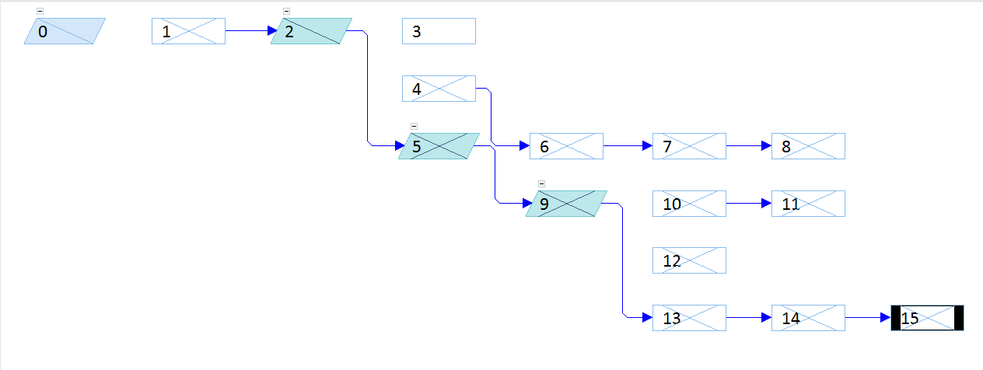

**CHAPTER 6: PROJECT RESOURCES**

* 1. **PEOPLE**

|  |  |
| --- | --- |
| **Developer** | **Roles and Responsibilities** |
| 14CE107 | Survey, Feasibility study, Documentation, Frontend developing, Testing. |
| 14CE145 | Implementation, Programming, Backend developing, Database management, Testing. |

User: Any user having basic knowledge of computer and internet services can use this software.

Developer: Developer with knowledge of .NET and C# web development can develop and work on this web portal.

* 1. **HARDWARE AND SOFTWARE**

|  |  |
| --- | --- |
| **Hardware** | **Software** |
| PC Specifications:  RAM:1 GB  Hard Disk: 500 GB  Windows Version: Windows XP and above. | Internet Explorer 9 and above. |

**CHAPTER 7: PROJECT TRACKING AND CONTROL PLAN**

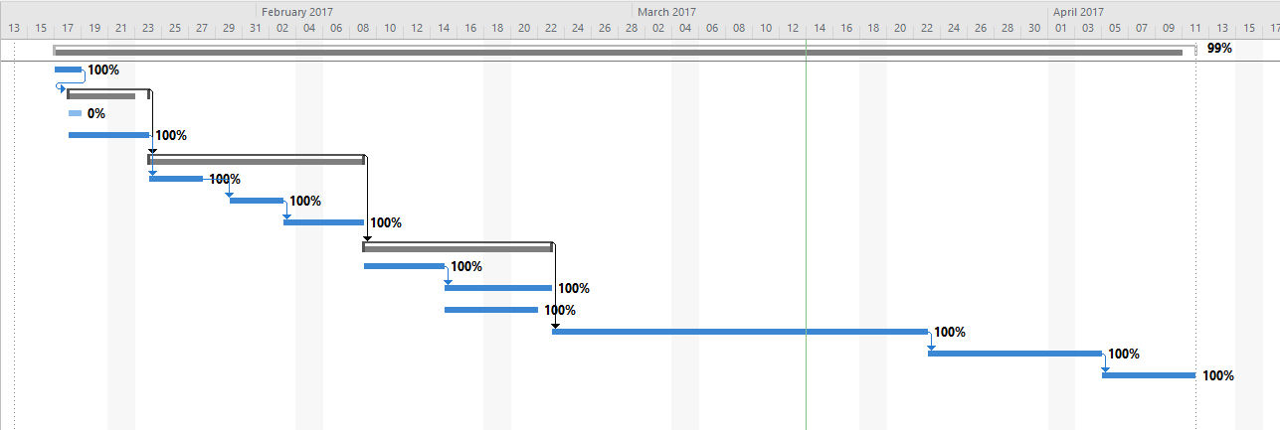

**CHAPTER 11: LIMITATION AND FUTURE ENHANCEMENT**

Limitation:

* Only collaborated hospitals can request for blood online.
* Limited to Web Browsers only.

Future Enhancement:

* This portal can be used to make Mobile platform application.
* Can be collaborated with other hospitals to provide more and more services in India and outside world.

**CHAPTER 12: CONCLUSION AND DISCUSSION**

* 1. **SELF ANALYSIS OF PROJECT VIABILITIES**
* We surveyed that maximum deaths in hospital occurs due to lack of availability of blood on time, this web portal is developed to overcome that.
* We also thought of android extension application for this web portal.
  1. **PROBLEM ENCOUNTERED AND POSSIBLE SOLUTIONS**
* There were so many problems related to implementation of Team Foundation Server and SSMS during implementation phase of project.
* To find best compatible version of SSMS that can work easily with VS 2015 was a tough job too.
  1. **SUMMARY OF PROJECT WORK**

We have developed a web portal for EBBMS that ensures the delivery of blood to door step of hospital within one hour or less after request has been done by hospital